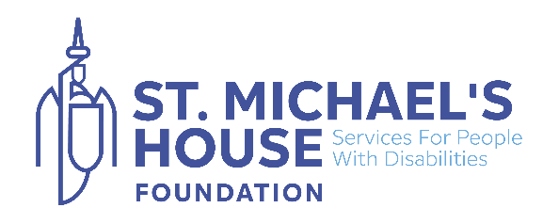
Brave the Waves – Frequently Asked Questions (FAQ)

1. What is Brave the Waves?
Brave the Wave is St. Michael’s House Foundation’s festive open-water challenge! Participants take a quick dip in the sea to support children and adults with intellectual disabilities across St. Michael’s House services.

2. When and where is it taking place?
The event takes place in December, at a time and place that suits you, once it is safe to do so.

3. Who can take part?
This event is for adults only (18+). It’s not recommended for children due to the risks associated with cold-water swimming.

4. Do I need to register?
Yes! Please register online to secure your place and receive event updates. Registration helps us manage safety numbers and ensure you get your Brave the Wave participant goodies!

5. How much does it cost to take part?
Registration is free, which includes your free swim hat and SMHF snood. We encourage participants to raise a minimum of €70.00 in sponsorship to support St. Michael’s House services.

6. What should I bring?
Swimwear (and something festive if you like!)
A brightly coloured swim cap or tow float for visibility
Warm clothes and towels for after your dip
Footwear suitable for entering and exiting the water safely
A flask with a warm drink to help you reheat after swimming

7. How long do we swim for?
This is a short, fun dip — most participants stay in the water for just a few minutes. Listen to your body and only stay in as long as you feel comfortable.

8. Is it safe?
Swimming Safety Guidelines
Your safety is our top priority. Please take a few moments to read the following advice before taking part in Brave the Waves:
- Never swim alone – always have someone with you or ensure a safety team is nearby.
- Make sure you can be seen – wear a brightly coloured swim cap or use a tow float.
- Check the weather and wind conditions before you swim.
- Know the tides – use an app such as Tides Near Me. It’s much safer to swim on a rising tide than a falling one.
- Swim within your depth – especially if you’re less experienced or new to open water.
- Listen to your body and tailor your swim to how you feel on the day.
- Be aware of marine life such as jellyfish and weever fish.
- If you have a medical condition, please consult your doctor before taking part.
- For further advice, visit Water Safety Ireland – Open Water Swimming.

9. Can my friends and family come to watch?
Absolutely! Supporters are very welcome to come along, cheer you on, and join in the festive spirit on the shore.

10. How does my fundraising help?
Every euro raised helps St. Michael’s House provide essential supports, therapies, and respite services for children and adults with intellectual disabilities — making a real difference in their lives.

